**CASETOOL LAB-2**

Name : Dinesh G Faculty: Ilakiyaselvan.N

RegNo :13MSE1148 Date: 9/11/17

**Question -1**

**Class Analysis Diagram**

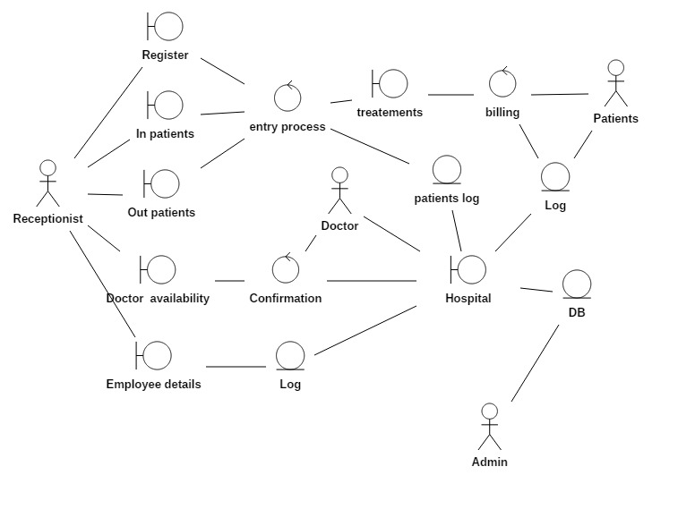

JForm Design

1. Registration

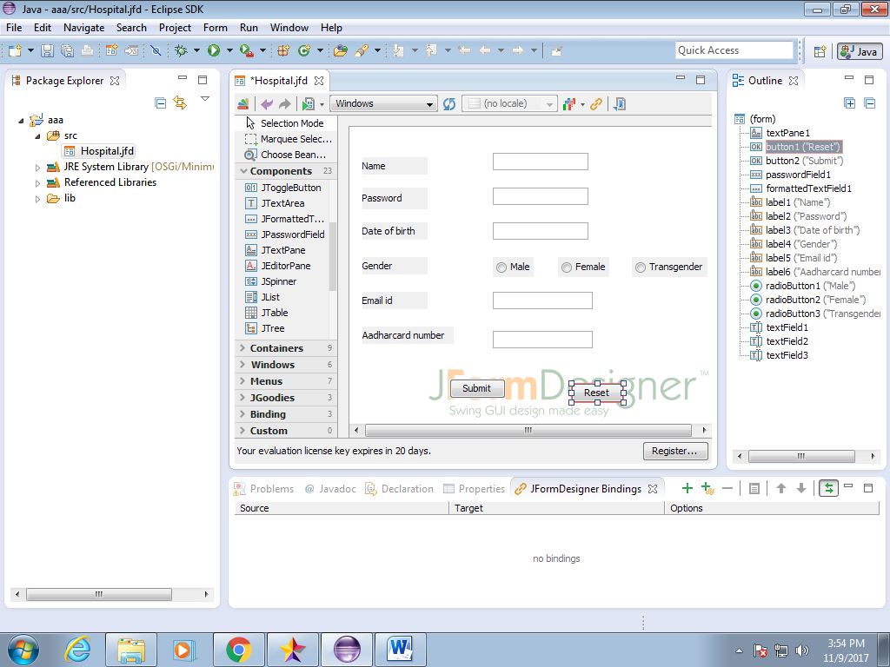

2-Login

